**Minor Project**

• **Project Name**:

Artificial Intelligence August Minor Project

• **Project Description**:

Problem statement: Create a Deep learning model to predict the different hand written digits ranging from 0 to 9

**Context**:

MNIST ("Modified National Institute of Standards and Technology") is the de facto “hello world” dataset of computer vision. Since its release in 1999, this classic dataset of handwritten images has served as the basis for benchmarking classification algorithms. As new machine learning techniques emerge, MNIST remains a reliable resource for researchers and learners alike. Each image is 28 pixels in height and 28 pixels in width, for a total of 784 pixels in total. Each pixel has a single pixel-value associated with it, indicating the lightness or darkness of that pixel, with higher numbers meaning darker. This pixel-value is an integer between 0 and 255. The training and test data sets have 785 columns. The first column consists of the class labels (see above), and represents the article of clothing. The rest of the columns contain the pixel-values of the associated image. Dataset can be downloaded as follows from tensorflow.keras.datasets import mnist (x_train, x_test),(y_train,y_test) = mnist.load_data()

**Details of datasets**:

Each target variable for training and testexample is assigned to one of the following labels:

• 0 • 1 • 2 • 3 • 4 • 5 • 6 • 7 • 8 • 9

These labels denote the hand written digits which can be plotted as well.

**Steps to consider**:

1. Normalize images by dividing pixels by 255 (if required)

2. Convert labels to categories (if required)

3. Build a CNN Architecture.

4. Execute the model for appropriate number of epochs

5. Depict loss vs. val_loss on line chart

6. Depict accuracy vs. val_accuracy on line chart.

7. Generate predictions on test_data

8. Compute Confusion matrix and classification report

**Solution:**

pip install numpy, tensorflow, keras, pillow,

import keras

from keras.datasets import mnist

from keras.models import Sequential

from keras.layers import Dense, Dropout, Flatten

from keras.layers import Conv2D, MaxPooling2D

from keras import backend as K

# the data, split between train and test sets

(x_train, y_train), (x_test, y_test) = mnist.load_data()

print(x_train.shape, y_train.shape)

x_train = x_train.reshape(x_train.shape[0], 28, 28, 1)

x_test = x_test.reshape(x_test.shape[0], 28, 28, 1)

input_shape = (28, 28, 1)

# convert class vectors to binary class matrices

y_train = keras.utils.to_categorical(y_train, num_classes)

y_test = keras.utils.to_categorical(y_test, num_classes)

x_train = x_train.astype('float32')

x_test = x_test.astype('float32')

x_train /= 255

x_test /= 255

print('x_train shape:', x_train.shape)

print(x_train.shape[0], 'train samples')

print(x_test.shape[0], 'test samples')

batch_size = 128

num_classes = 10

epochs = 10

model = Sequential()

model.add(Conv2D(32, kernel_size=(3, 3),activation='relu',input_shape=input_shape))

model.add(Conv2D(64, (3, 3), activation='relu'))

model.add(MaxPooling2D(pool_size=(2, 2)))

model.add(Dropout(0.25))

model.add(Flatten())

model.add(Dense(256, activation='relu'))

model.add(Dropout(0.5))

model.add(Dense(num_classes, activation='softmax'))

model.compile(loss=keras.losses.categorical_crossentropy,optimizer=keras.optimizers.Adadelta(),metrics=['accuracy'])

hist = model.fit(x_train, y_train,batch_size=batch_size,epochs=epochs,verbose=1,validation_data=(x_test, y_test))

print("The model has successfully trained")

model.save('mnist.h5')

print("Saving the model as mnist.h5")

score = model.evaluate(x_test, y_test, verbose=0)

print('Test loss:', score[0])

print('Test accuracy:', score[1])

from keras.models import load_model

from tkinter import *

import tkinter as tk

import win32gui

from PIL import ImageGrab, Image

import numpy as np

model = load_model('mnist.h5')

def predict_digit(img):

#resize image to 28x28 pixels

img = img.resize((28,28))

#convert rgb to grayscale

img = img.convert('L')

img = np.array(img)

#reshaping to support our model input and normalizing

img = img.reshape(1,28,28,1)

img = img/255.0

#predicting the class

res = model.predict([img])[0]

return np.argmax(res), max(res)

class App(tk.Tk):

def __init__(self):

tk.Tk.__init__(self)

self.x = self.y = 0

# Creating elements

self.canvas = tk.Canvas(self, width=300, height=300, bg = "white", cursor="cross")

self.label = tk.Label(self, text="Thinking..", font=("Helvetica", 48))

self.classify_btn = tk.Button(self, text = "Recognise", command = self.classify_handwriting)

self.button_clear = tk.Button(self, text = "Clear", command = self.clear_all)

# Grid structure

self.canvas.grid(row=0, column=0, pady=2, sticky=W, )

self.label.grid(row=0, column=1,pady=2, padx=2)

self.classify_btn.grid(row=1, column=1, pady=2, padx=2)

self.button_clear.grid(row=1, column=0, pady=2)

#self.canvas.bind("<Motion>", self.start_pos)

self.canvas.bind("<B1-Motion>", self.draw_lines)

def clear_all(self):

self.canvas.delete("all")

def classify_handwriting(self):

HWND = self.canvas.winfo_id() # get the handle of the canvas

rect = win32gui.GetWindowRect(HWND) # get the coordinate of the canvas

im = ImageGrab.grab(rect)

digit, acc = predict_digit(im)

self.label.configure(text= str(digit)+', '+ str(int(acc*100))+'%')

def draw_lines(self, event):

self.x = event.x

self.y = event.y

r=8

self.canvas.create_oval(self.x-r, self.y-r, self.x + r, self.y + r, fill='black')

app = App()

mainloop()

**Screenshots:**

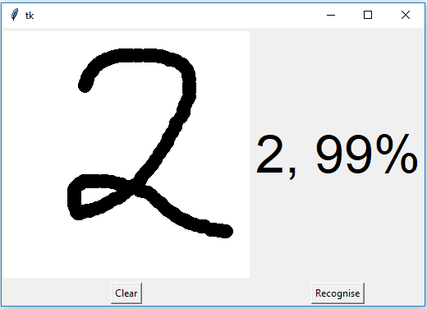

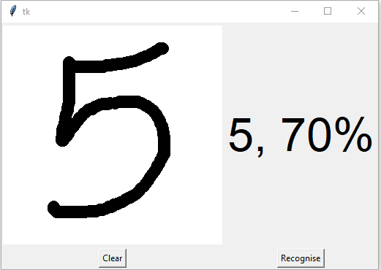

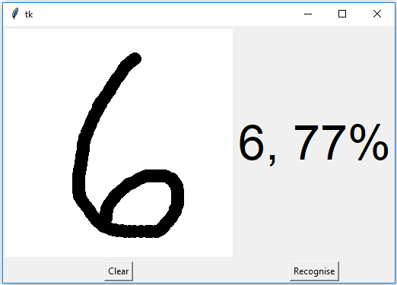

## **Summary**

We have successfully built a Python deep learning project on handwritten digit recognition app. We have built and trained the Convolutional neural network which is very effective for image classification purposes. Later on, we build the GUI where we draw a digit on the canvas then we classify the digit and show the results.

Project by

M KARISMA SATYA SAI LAKSHMI